Marketing Guide

Background
Background information:

According to the CDC, approximately 90% of American healthcare spending is for chronic conditions such as diabetes, heart disease, and obesity. If we extrapolate this to Kaiser Permanente’s annual operating costs, we estimate that we spend over $13.6 billion per year on chronic diseases. However, many of these conditions are preventable. As a result, other healthcare companies, such as Cigna and Optima Health, are turning to the use of digital therapeutics to help control costs. For this reason, Kaiser Permanente management has expressed a desire to expand our offerings in the preventative care space.

Problem:

Kaiser Permanente has long been recognized as a leader in preventative care. Over the years we have developed a number of resources and toolkits, however these are currently scattered across various locations and platforms and cannot be accessed by all 12.2 million of our members. We could choose an off-the-shelf digital therapeutic solution such as Omada, but it focuses on managing already existing chronic conditions, not necessarily on preventing their occurrence in the first place.

As an integrated managed care provider, we have access to both patient care data, as well as insurance cost data. This presents a real opportunity for us to distinguish ourselves from our competitors. We propose to integrate all of our tools and experience into a new mobile app, focusing on both prevention and chronic disease management. Assuming we see a success rate similar to the competition, we estimate cost savings of over $1.1 billion.

Product Goals:
- Provide the user with functions to help prevent chronic disease, as well as to manage any existing conditions
- Increase overall member health and satisfaction
- Use data acquired through the app to improve the patient’s care

Market background
Target market:

Our target market includes adult Americans between the ages of 18 up to 65 who could potentially choose Kaiser Permanente as their healthcare provider. This includes approximately 193 million people. (Source: https://www.statista.com/statistics/241488/population-of-the-us-by-sex-and-age/)

Target audience:

Our target audience includes all Kaiser Permanente members (customers), of which there are currently approximately 12.2 million. However, within this audience, we are particularly interested in attracting users who are already suffering from a chronic condition such as obesity, diabetes or cardio-vascular disease, or are currently at risk for developing one. Helping these members control their disease through daily monitoring and use of the app will help us realize our goals of increased customer health and happiness, as well as decreased spending for chronic conditions.

Competitors:

There are two apps that stand out in doing both weight management (activity and nutrition logging), as well as chronic disease management: Omada and Livongo. We will make the assumption that these are the two best candidates with which to compare our proposed app.

Omada is digital therapeutics company with an estimated annual revenue of $104 million. (Source: https://www.owler.com/company/omadahealth). As of 2018 they had approximately 85,000 users (Source : https://www.fastcompany.com/company/omada-health). It should be noted that Kaiser Permanente is an investor. Omada focuses particularly on diabetes, hypertension and behavioral health management. Additionally, they offer coaching and social networking features inside the app. Users are also provided with a smart scale to be used with the app. Their customers include Cigna, Blue Cross Blue Shield, Optima Health, and some Kaiser Permanente locations.

Livongo is another digital therapeutics company that has been rapidly growing. Their estimated annual revenue is $290 million and they claim to have 207,000 members (Source: https://www.owler.com/company/livongo). They recently purchased the myStrength behavioral health app that Kaiser Permanente uses. Livongo focuses mainly on diabetes, hypertension, behavioral health and weight management. They offer coaching and prescription refills within the app. In addition to a smart scale, they provide users with glucose readers and blood pressure monitors. Their customers include Mount Sinai Group, Mission Health, and Blue Cross Blue Shield. Additionally, Medicaid and Medicare customers are eligible.

Product Background and Positioning
Value proposition:

KPDailyCheckup will serve as a one-stop-shop preventative health app for all Kaiser Permanente members. By doing so it will increase member health and satisfaction, while reducing our spending on chronic preventable diseases.

Key Features of the product:

Feature | Description
User Accounts | Users can create accounts based on their member id and other person information.  Users can log in to the account they created. They should also be able to change their password if necessary.
Meal Logging | Users should be able to add, modify and delete food items and nutrition (calorie) information for meals. Meal categories include breakfast, lunch, dinner and snacks.  The user should be able to view the information that they’ve entered in (via the daily log) and see a running tally of the total calories they have consumed that day.  Users should be able to search for food items to add via a large database that contains calorie/nutrition information.
Activity Logging | Users should be able to add, modify and delete exercise activity. Calories burned should be calculated automatically based on the activity type, user’s weight and minutes exercised.  If the user has not yet entered in their weight, they should be prompted to do so.  The user should be able to view the information that they’ve entered in (via the daily log) and see a running tally of the total minutes exercised and calories burned for that day.  Users should be able to search for activity types to add via database that contains activity information. If the user does not find their activity type they should be able to manually add the activity and calories burned.
Daily Log | The user should see a summary of the data that they’ve entered into the app for the given day. This should include:  - Meals  - Physical activity  - Other health data (See the health data section below.)  The user should be able to see the total calories consumed by meal, as well as an overall total. They should also be able to see the total amount of calories that they’ve burned.

Screenshots:

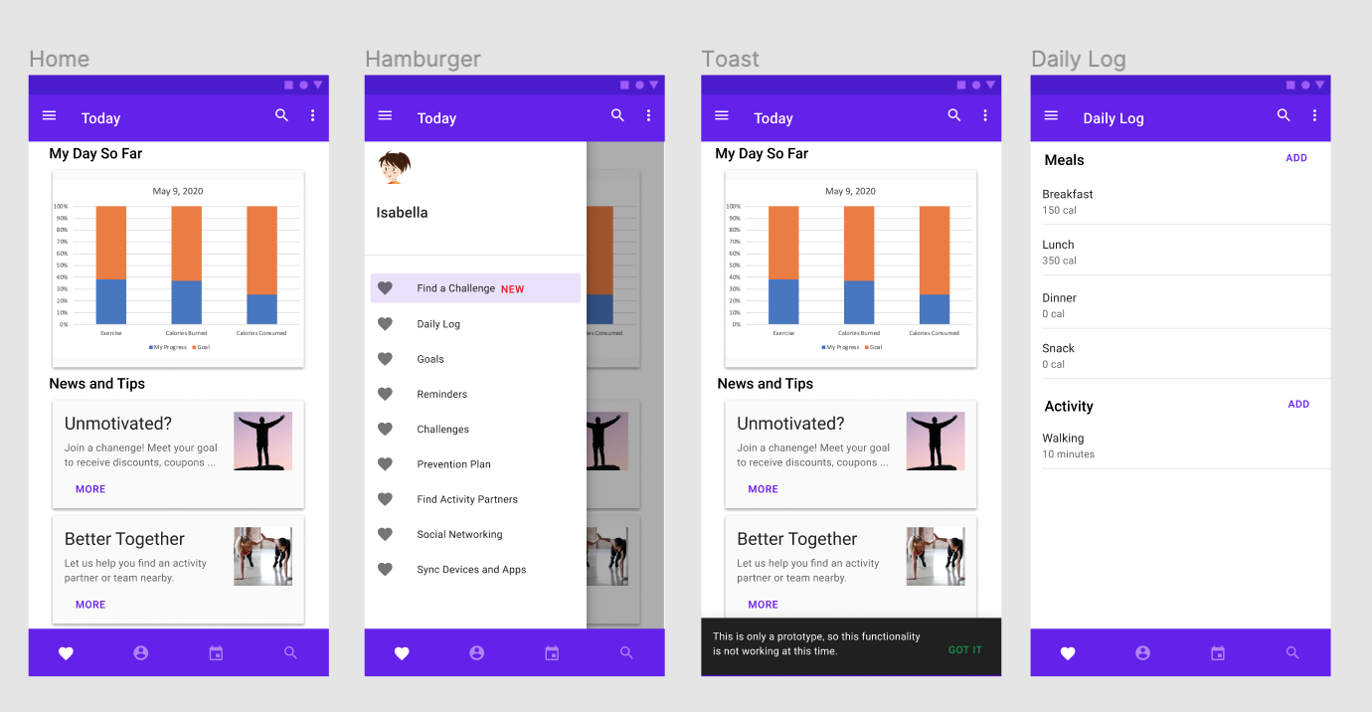

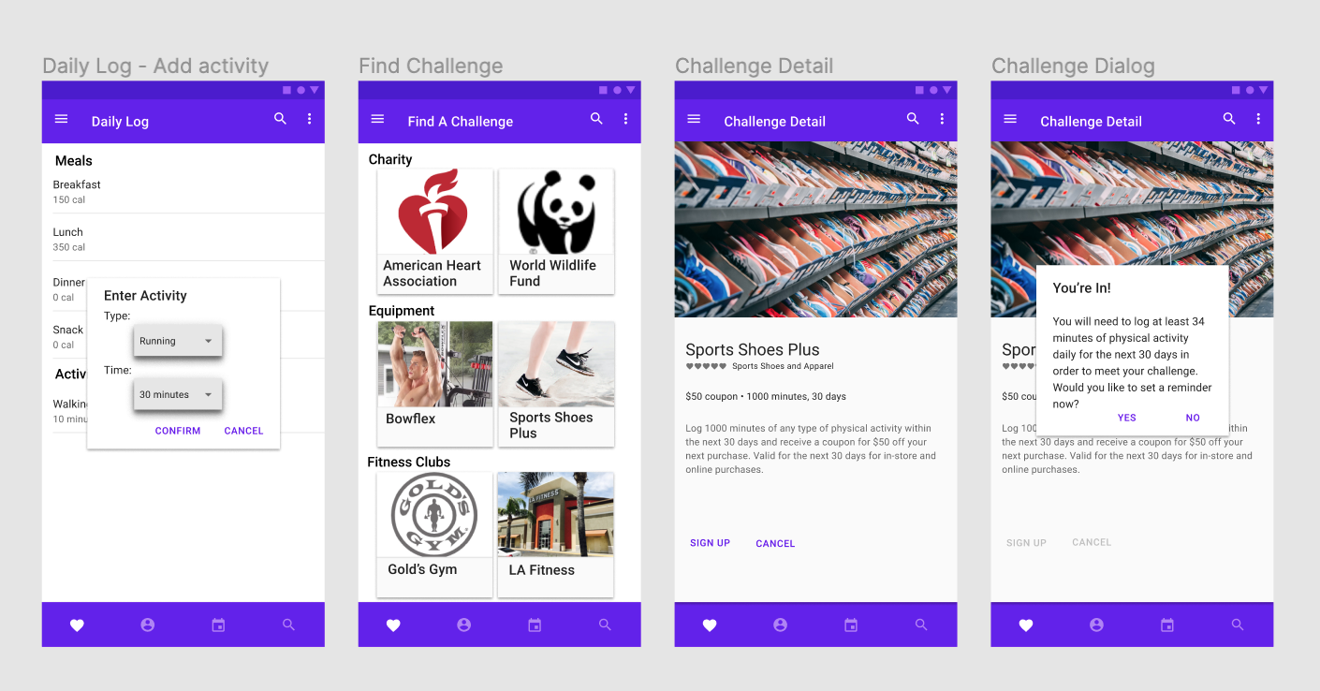

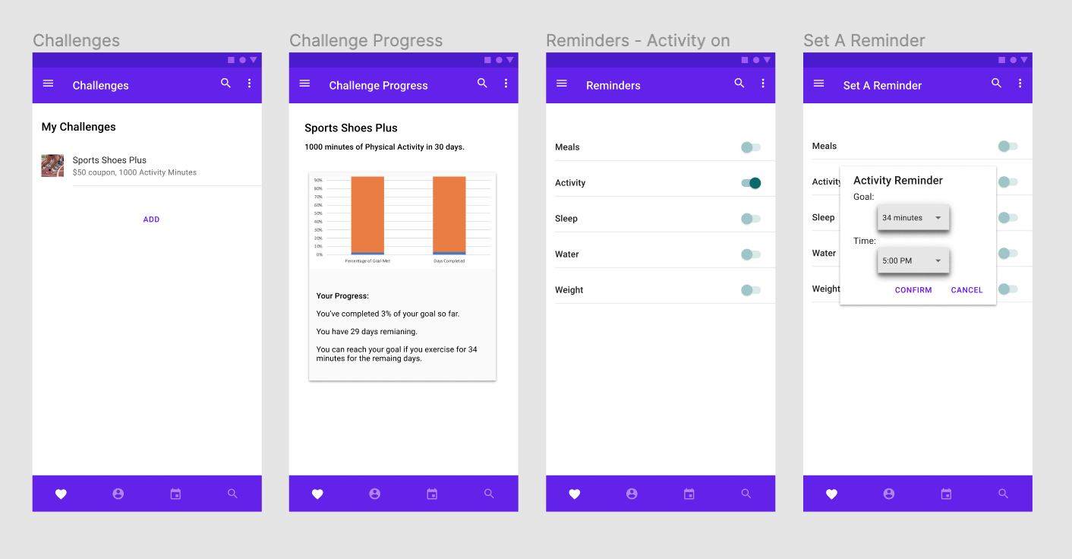

Benefits to users and consumers:
- A one-stop-shop for information about preventative health, making easy to be one’s healthiest
- Customized preventative health plan to help users prevent chronic disease or manage an existing condition
- Easy communication between patients and chronic care managers about health issues and progress

How to use the product:
After opening the app on your mobile phone, you will be prompted for your member id and password, if you are not already logged into the app. You will also have the option to create a new account if you have not yet done so.

After a successful login, the Today screen appears and shows the amount of progress you’ve made towards your goals for minutes exercised, calories-burned and calories consumed (what you’ve eaten). Below that you will see a list of helpful tips and news.

You can navigate through the product via the hamburger menu on the left-hand side of the screen. Simply click the three bars on the top left-hand side of the screen to open the menu.

Please see the “User Guide” document for further detailed information.

Where users can find the product:
Users will be able to download the product from either the Apple App Store (iPhone or iPad) or from the Google Play Store (Android devices). Links to both of these will also be provided on Kaiser Permanente’s website, in its ‘Health & Wellness’ section.

